7.1.31 Editors - 3D Viewport - Header - Point Cloud - Edit mode - Point Cloud menu

Table of Content
Edit Mode - Point Cloud Menu 3
Transform sub menu 3
To Sphere 3
Usage 3
Last Operator To Sphere 3
Factor 3
Proportional editing 3
Proportional Falloff 3
Proportional Size 3
Connected 3
Projected(2D) 4
Shear 4
Last Operator Shear 4
Offset 4
Shear Axis 4
Axis 4
Axis Ortho 4
Orientation 4
Proportional editing 4
Proportional Falloff 4
Proportional Size 4
Connected 5
Projected(2D) 5
Bend 5
Push/Pull 5
Last Operator Push/Pull 5
Factor 5
Proportional editing 5
Proportional Falloff 5
Proportional Size 5
Connected 5
Projected(2D) 5
Warp 6
Last operator Warp 6
Warp Angle 6
Offset Angle 6
Min 6
Max 6
Randomize 6
Last Operator Randomize Transform 6
Random Seed 6
Transform Delta 6
Randomize Location checkbox 6
Location edit boxes 6
Randomize Rotation checkbox 6
Rotation edit boxes 6
Randomize Scale checkbox 7
Scale Even 7
Scale edit boxes 7
Radius 7
Move Texture Space 7
Last Operator Move 7
Move 7
Orientation 8
Proportional editing 8
Proportional Falloff 8
Proportional Size 8
Connected 8
Projected(2D) 8
Scale Texture Space 8
Last Operator Resize 8
Move 8
Orientation 8
Proportional editing 8
Proportional Falloff 9
Proportional Size 9
Connected 9
Projected(2D) 9
Point Cloud menu 9
Duplicate 9
Last Operator Duplicate 9
Move X , Y , Z 9
Orientation 9
Mirror Editing 9
Proportional editing 9
Proportional Falloff 9
Proportional Size 10
Connected 10
Projected(2D) 10
Set Attribute 10
Last Operator Set Attribute 10
position X , Y , Z 10
Delete 10
Separate 10

Edit Mode - Point Cloud Menu
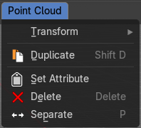

Transform sub menu

The transform sub menu contains functionality for some kind of transformations.

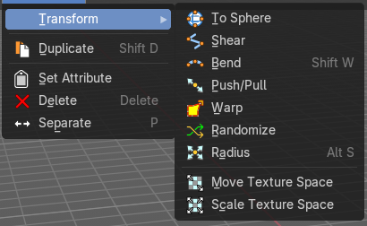
To Sphere
Shapes a selection into the shape of a sphere. The calculation happens with the object origins.

Usage

Select the objects, activate the tool, then drag the mouse in the 3D viewport. In the header you will read the current factor then. Which tells you how close you are towards the sphere shape.
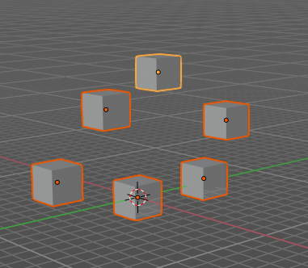
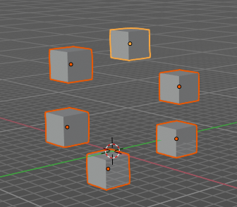


Last Operator To Sphere

Factor
The factor to transform the selection into a shape form.


Proportional editing
Enables proportional editing. Activating proportional editing reveals further settings.

Proportional Falloff
Adjust the falloff methods.

Proportional Size
See and adjust the falloff radius.

Connected
The proportional falloff gets calculated for connected parts only.

Projected(2D)
The proportional falloff gets calculated in the screen space. Depth doesn't play a role. When it's in the radius, then it gets calculated.

Shear
Shear shears the selection.
In Object mode this tools requires to have more than one object selected.


Last Operator Shear

Offset
Adjust an offset.

Shear Axis
The shear tool works along a imaginary 2d plane. The shear axis controls if the items are sheared along the x or the y axes of this plane. This is the plane along which the transformation happens. You can shear along the x or the y axis of this plane.
To make things even more complicated, the orientation of this imaginary plane is defined by the Axis and Axis Ortho items below.

Axis
Defines one axis of the imaginary shear axis plane.


Axis Ortho
Defines the other axis of the imaginary shear axis plane.

Orientation
Choose the orientation for the shear action.

Proportional editing
Enables proportional editing. Activating proportional editing reveals further settings.

Proportional Falloff
Adjust the falloff methods.

Proportional Size
See and adjust the falloff radius.

Connected
The proportional falloff gets calculated for connected parts only.

Projected(2D)
The proportional falloff gets calculated in the screen space. Depth doesn't play a role. When it's in the radius, then it gets calculated.

Bend
Bends the selection.

Push/Pull
It pushes or pulls the object positions relative to the center of the selection.
In Object mode this tool requires to have more than one object selected.


Last Operator Push/Pull

Factor
Adjust the strength of influence of the tool.

Proportional editing
Enables proportional editing. Activating proportional editing reveals further settings.

Proportional Falloff
Adjust the falloff methods.

Proportional Size
See and adjust the falloff radius.

Connected
The proportional falloff gets calculated for connected parts only.

Projected(2D)
The proportional falloff gets calculated in the screen space. Depth doesn't play a role. When it's in the radius, then it gets calculated.


Warp
Warps a selection between two defined points. This also works with curves.

Last operator Warp

Warp Angle
The strength of the warp effect.

Offset Angle
An offset angle to bend side wards.


Min
The start point.

Max
The end point.

Randomize
This tool allows to randomize position rotation and scale of selected objects. Each object gets threaten individually by a random value.
It starts with zeroed values. You need to adjust the values in the last operator.

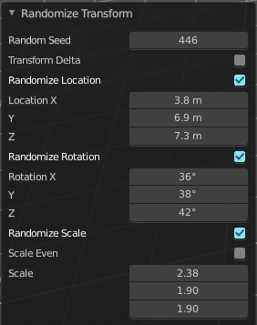
Last Operator Randomize Transform

Random Seed
Adjust the random seed value.

Transform Delta
Randomize Delta transform values instead of the regular transform values.

Randomize Location checkbox
With this checkbox ticked the location of the selected objects gets randomize

Location edit boxes
Adjust the strength of the transform for the single axis.

Randomize Rotation checkbox
With this checkbox ticked the rotation of the selected objects gets randomize

Rotation edit boxes
Adjust the strength of the transform for the single axis.

Randomize Scale checkbox
With this checkbox ticked the scale of the selected objects gets randomized.

Scale Even
Use the same scale values for all axis.

Scale edit boxes
Adjust the strength of the transform for the single axis.

Radius
Scales the selected point along its normals.
A positive value pushes the vertices width outwards. A negative value pushes the vertices width inwards.
Notes: Transform orientation and Pivot point gets ignored. To see the result, make sure you have geometry radius applied, without this will be set into the Radius attribute.

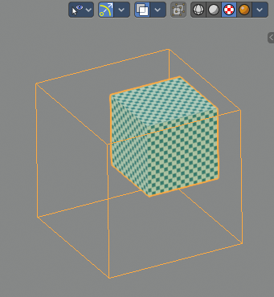
Move Texture Space
This tool relies at the move tool. With the difference that it moves the texture space instead of the object. It has also a very special use case, and just works with a material with a Texture Coordinate / Generated node. And requires to have the shading at Material or Rendered to see a result in the viewport.
The yellow cage represents the texture space. The actual UV mapping does not change.
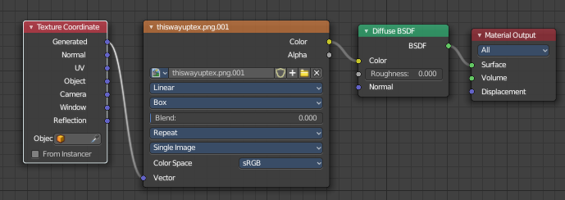

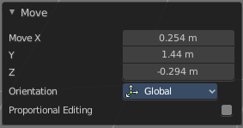
Last Operator Move

Move
Adjust in which directions you want to transform.

Orientation
Choose the orientation.

Proportional editing
Enables proportional editing. Activating proportional editing reveals further settings.

Proportional Falloff
Adjust the falloff methods.

Proportional Size
See and adjust the falloff radius.

Connected
The proportional falloff gets calculated for connected parts only.

Projected(2D)
The proportional falloff gets calculated in the screen space. Depth doesn't play a role. When it's in the radius, then it gets calculated.

Scale Texture Space
Scale Texture space is similar to the Move texture Space. With the only difference that it scales the UV space instead of moving it.

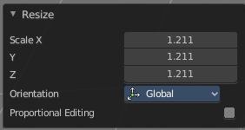
Last Operator Resize

Move
Adjust in which directions you want to transform.

Orientation
Choose the orientation.

Proportional editing
Enables proportional editing. Activating proportional editing reveals further settings.

Proportional Falloff
Adjust the falloff methods.

Proportional Size
See and adjust the falloff radius.

Connected
The proportional falloff gets calculated for connected parts only.

Projected(2D)
The proportional falloff gets calculated in the screen space. Depth doesn't play a role. When it's in the radius, then it gets calculated.

Point Cloud menu

Duplicate
Duplicates the current selection. This can be a single control point or a whole curve.
The copy sticks to the mouse until you release it. A Right click while moving will reset the position of the duplicate. The duplicated part will be part of the same object.
When you drag the duplicate around you will see the position values in the header.

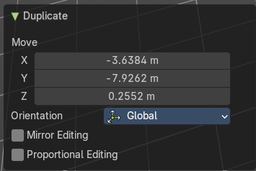
Last Operator Duplicate

Move X , Y , Z

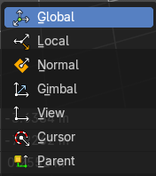
Orientation
Choose the orientation.

Mirror Editing
Mirror editing.

Proportional editing
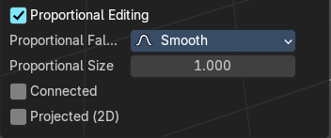
Enables proportional editing. Activating proportional editing reveals further settings.

Proportional Falloff
Adjust the falloff methods.

Proportional Size
See and adjust the falloff radius.

Connected
The proportional falloff gets calculated for connected parts only.

Projected(2D)
The proportional falloff gets calculated in the screen space. Depth doesn't play a role. When it's in the radius, then it gets calculated.

Set Attribute
Set values of the active attribute for selected elements.

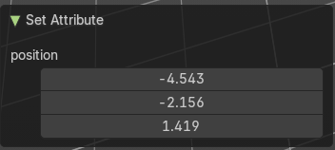
Last Operator Set Attribute

position X , Y , Z

Delete
Deletes the selected element.

Separate
Separates the selection and makes a new object out of it.

